# CFD Software Team

### To-Do List:

Current

* Run simulations on design Option 1 and Option 2
  + Group 1 = Jorik, Dhruv, Jeyan, Samantha
    - Use the Option 1 Assembly STEP file
    - CFD > Current > Simulations > STEP files
  + Group 2 = Izzy, Lexi, Mia
    - Use the Option 2 Assembly STEP file
* Import into ANSYS Workbench on virtual lab and run simulations
  + Reference ANSYS Fluent Simulation Example video if new to cfd software
    - CFD > Current > Software
  + Example simulations can be used as a reference
    - CFD > Current > Simulations > ANSYS > Option1 or Option 2>

Option 1 Simulation Trial 1 or Option 2 Simulation Trial 1

* + Save the files in appropriate folder (Option 1 or Option 2) in ANSYS folder
    - Name the file as “Option # Simulation Initials”
    - Example: Option 1 Simulation JS
* Record simulation values and results in the Simulation Results spreadsheet
  + Add values from results as well as screenshots of contours and graphs to excel
    - See Post-processing Results under ANSYS in this google doc for instructions
    - Open CFD Post (right click on Results and Edit) and use the Function Calculator for finding max & avg velocity and pressure
  + When finished with the first simulation, change the outlet pressure to the 24 inches of water instead of 4 inches of water and record those results as well
  + Location of excel spreadsheet: CFD > Current > Simulations

Eventually

* Write or update protocol for running simulation
* Possibly run same simulations in another software to verify/validate results
  + Ask about FEBio boundary conditions, help from someone who has used FEBio Fluid Mechanics

Continuous

* Find useful resources/links like tutorials
* Check CFM folder for updates on their software research

### Boundary Conditions Needed

* MatWeb is a valuable resource for material properties (<http://www.matweb.com/>)
  + Use text search for specific material or physical properties search
  + Useful for friction and elasticity values for chamber material
* Values from Gerald
  + Inlet pressure: 0.25N / 83,000 Pa
  + Outlet pressure: 4 inches of water (995.36Pa)
  + Length of surgical catheter: 30 cm
* OpenFOAM
  + Physics model
    - Is flow incompressible or compressible?
    - Is flow laminar or kOmegaSST (turbulence)?
  + Fluid Properties
    - Density
    - Dynamic viscosity
  + Boundary Conditions
    - Inlet: velocity, pressure
    - Outlet: velocity, pressure
    - Walls: slip or no slip
* FEBio
  + Fluid
    - Density
    - Bulk modulus
    - Shear viscosity
    - Bulk viscosity
  + Boundary conditions

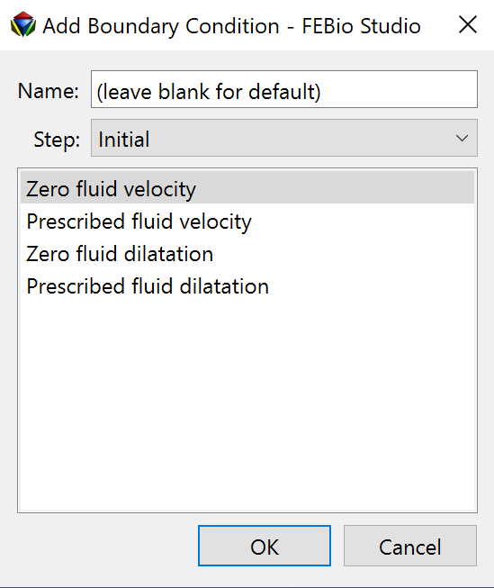

* Ansys
  + Setup > Models
    - What type of Viscous flow? Laminar, inviscid, k-omega, etc.
  + Materials > Fluid
    - Density
    - viscosity
  + Boundary conditions > Inlet
    - Velocity magnitude (m/s)
    - Initial gauge pressure (Pa)
  + Boundary conditions > Outlet
    - Gauge pressure (Pa)
  + Boundary conditions > Walls
    - Shear condition is it no slip or is there shear?

### 

### FreeCAD OpenFOAM

#### Software Specifications/Requirements

* Windows 64-bit installer, Mac 64-bit dmg, or Linux 64-bit Applmage
  + Windows 7 is the minimum supported version
  + Mac OSX 10.12 Sierra is the minimum supported version
* Minimum system requirements:
  + gcc: 4.8.5
  + cmake: 3.3 (required for ParaView and CGAL build)
  + boost: 1.48 (required for CGAL build)
  + fftw: 3.3.7 (optional - required for FFT-related functionality)
  + Qt: 4.8 (optional - required for ParaView build)
* Recommended hardware specifications:
  + High RAM (1 million cells requires 1 GB of RAM)
  + Good CPU (central processing unit)
  + 1 TB hard-drive (avoid SSD disks)
  + Good graphics card

#### Features

* Incompressible, laminar flow (simpleFoam, pimpleFoam)
* Incompressible free-surface flow (interFoam, multiphaseInterFoam)
* High-speed compressible flow ([HiSA](https://hisa.gitlab.io))
* Basic material database
* Flow initialisation with a potential solver
* Cut-cell Cartesian meshing with boundary layers (cfMesh)
* Cut-cell Cartesian meshing with porous media (snappyHexMesh)
* Tetrahedral meshing using GMSH
* Post-processing using ParaView
* Porous regions and porous baffles
* Unit testing
* Extension to turbulent flow using RANS (k-w SST)
* New case builder using an extensible template structure
* Macro scripting

#### Steps to Download

* Downloading FreeCAD
  + <https://www.freecadweb.org/downloads.php>
* Setting up CfdOF Workbench (uses OpenFOAM)
  + Start FreeCAD
  + Select Tools > Addon manager, this brings up a list of workbenches
  + Select Plot, click “Install/update” and restart FreeCAD
  + Select Tools > Addon manager
  + Select CfdOF, click “Install/update”, and restart FreeCAD
* Installing Dependencies
  + Windows: Select Edit > Preferences > CfdOF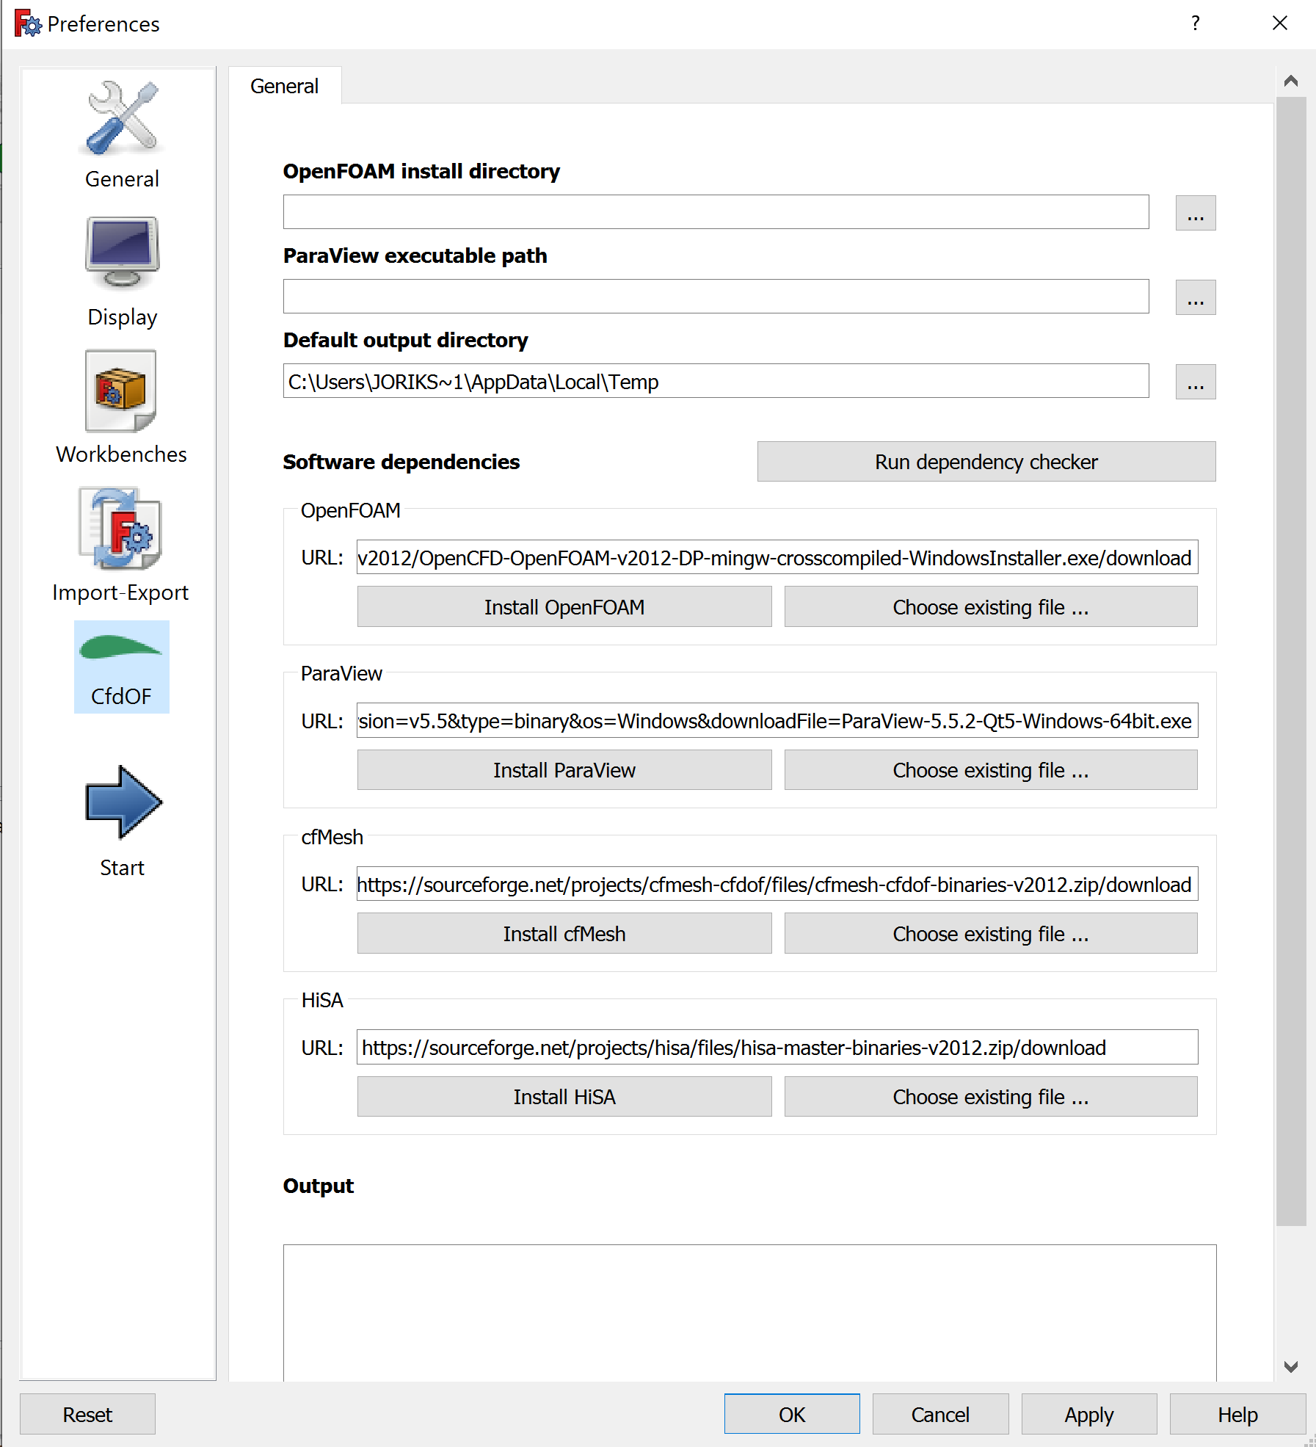
  + Mac: Select FreeCAD > Preferences > CfdOF
    - NOTE: Mac users experienced issues accessing this page. It showed up blank making it impossible to download the dependencies.
  + Install OpenFOAM, ParaView, cfMesh, and HiSA
    - If prompted to run as administrator, close the app, right-click on the app and select “Run as Administrator” to open it again
  + To make sure everything is installed, run the dependency checker

#### Resources

* <https://www.opensim.co.za/training.html> - Website with links to pdf tutorials
* <https://www.youtube.com/watch?v=7i_K7fo8BSk> - Video of creating part and running fluid simulation. The CfdOF tutorial part of the video starts at around 10:30.
* Information from CFM
  + Modeling Drive > LAA LA CFM > Current > Software Research > OpenFOAM or FreeCAD folders or CFM Software Research word doc

#### Creating Fluid Domain in SolidWorks

* <https://www.youtube.com/watch?v=V1zHcBw7hCA> - reference video
* For an assembly
  + Open the assembly
  + Go to Insert Components, click the expand arrow, select New Part
    - Recommended: rename the new part to Fluid or Internal Volume
  + Right click the new part and select Edit Part
  + Go to the Insert tab at the top of the screen and select Features > Join
    - Select all of the existing parts in the assembly, click the green check mark
  + Right click the part and select Open Part (this opens the part in its own window)
  + Create Planes at the ends of the part, similar to caps
    - Reference Geometry > Plane works well
  + In Features, choose the Intersect command
    - Select the two end planes as well as the Join solid, and then hit Intersect
    - Uncheck Merge result
    - Under Regions to Exclude, exclude all regions except the internal volume
    - Hit the green check mark
  + If done correctly, the intersect command should have created a new solid of the internal volume. Save this file as an STL file.
* For a part file
  + Skip to the instructions after Open Part and follow the same steps

#### Instructions for Importing a SolidWorks File

* Open the desired part in SolidWorks or another modeling software and save it as an STL file.
* In FreeCAD click create new. To import a file, you should first go to File in the upper left corner and then click on import.
  + From here you should select the .STL file that has been saved that you want to import.
  + After selecting the file, click open to get the contents of the file in the main workspace of FreeCAD.
* Once the file is opened in FreeCAD, changes can be made to this file, but the possible changes are limited.
* To edit the .STL file, you have to change it into a solid.
  + First make sure you have the Part workbench open. Then select the object, go to Part at the top of the window, and then click on Create shape from mesh.
    - Select OK for the default tolerance. This can be modified if necessary.
  + Next, select the new object, go to Part > Create a copy and click on Refine shape
  + Finally, select the new object, go to Part and select Convert to solid
  + You can right click and select toggle visibility to suppress the other parts
    - Another way to suppress a part is to select it and hit the spacebar
* You can repair the .STL file in FreeCAD using the Mesh Design workbench.
  + Go to Meshes > Analyze > Evaluate and repair mesh
  + Under Mesh information select the object
  + Can test everything by first choosing “All above tests together” and then hitting analyze.
  + To complete the repair, hit repair after the analysis is done.

[Editing stl files - YouTube](https://www.youtube.com/watch?v=x6ESAAfFT1A)– basics of importing and editing .STL files

[Modify STL 3D printing files with FreeCAD – Pinter Computing](http://pinter.org/archives/4255) - importing and editing .STL files

[7 Free STL Editors: How to Edit & Repair STL Files | All3DP](https://all3dp.com/1/7-free-stl-editors-edit-repair-stl-files/#:~:text=1%20Open%20STL%20file%20and%20convert%20it%20to,repair%20mesh.%20...%204%20Export%20as%20STL%20file) - repairing .STL files

#### Test Simulation Progress/Comments

* Importing the file was easy
  + Had to create internal fluid domain in SolidWorks
  + Not hard, just requires extra step of accessing solidworks file and creating a new stl file
* General process
  + Open CfdOF Workbench, click CfdAnalysis
  + Physics Model
    - Time -> steady
    - Flow -> Single Phase, Incompressible
    - Viscous -> Laminar
  + Fluid Properties
    - Can select water (density 1e+03 kg/m^3, dynamic viscosity 1e-06 kg/mm*s)
    - Can create custom fluid
  + Create Boundaries
    - Walls, inlet, outlet
  + Mesh
    - gmsh
  + Initialize
    - Potential flow or use value from boundary
  + CFD solver
    - Write case, run
* I keep getting an error in my simulation, don’t know why
  + I changed parallel cores to false
  + Changed end time to 100 and time step to 1
  + These changes solved the error
* Overall comments
  + Compared to Ansys, setup is simpler. The mesh and boundary conditions can all be created in the same window instead of having to switch to different programs
  + Initialize fields with potential flow and setting the values for the boundary conditions is a little more confusing
  + Viewing results with Paraview is easy, understanding the values and what they represent is less straightforward than with Ansys Fluent

### 

### FEBio

#### Software Specifications / Requirements

* pre-compiled executables for Windows, Mac OS X, and Linux platforms are available

#### Features

* Nonlinear elasticity and viscoelasticity
  + Compressible solids
  + Nearly-incompressible solids
  + Isotropic, transversely isotropic and orthotropic elasticity
* Rigid body mechanics
* Multiphasic mechanics
* Interstitial growth mechanics
* Heat conduction
* Computational fluid dynamics
* Fluid-solid interaction (FSI)
* Reaction-diffusion (via FEBioChem plugin)
* DOES NOT have mesh generation capabilities
  + Input files need to be generated by preprocessing software (preferred preprocessor for FEBio is PreView)

#### Steps to Download

* In order to download FEBio, you first need to register an account on febio.org
  + To register for an account:
    - Go to: <https://febio.org/register/>
    - Fill out the form with your name, email address, and the Institution to which you belong
      * (Use your school email not FMT to actually be able to register with your Institution)
    - Choose a unique username and a password
    - Check the box labeled “I agree to license terms” to accept the license agreement.
    - Click “submit”
    - You will get an email with a link from FEBio to activate your account. Click the link.
    - A notification saying “Your account is now activated. Log in here.”
    - Log in using the username and password you just set at registration.
    - Click “I agree to the terms '' under the username and password to accept Google’s reCAPTCHA and proceed.
* After registering your new account, you can download FEBio Studio.
  + To download FEBio Studio:
    - Go to: <https://febio.org/downloads/> or click the Downloads link in the menu bar at the top of the website
      * NOTE: If you are not already logged in to your account, you will be asked to login on the Downloads page. After logging in, download links will appear for each operating system.
    - Click the blue “download” button for the software package appropriate for your respective operating system.
      * 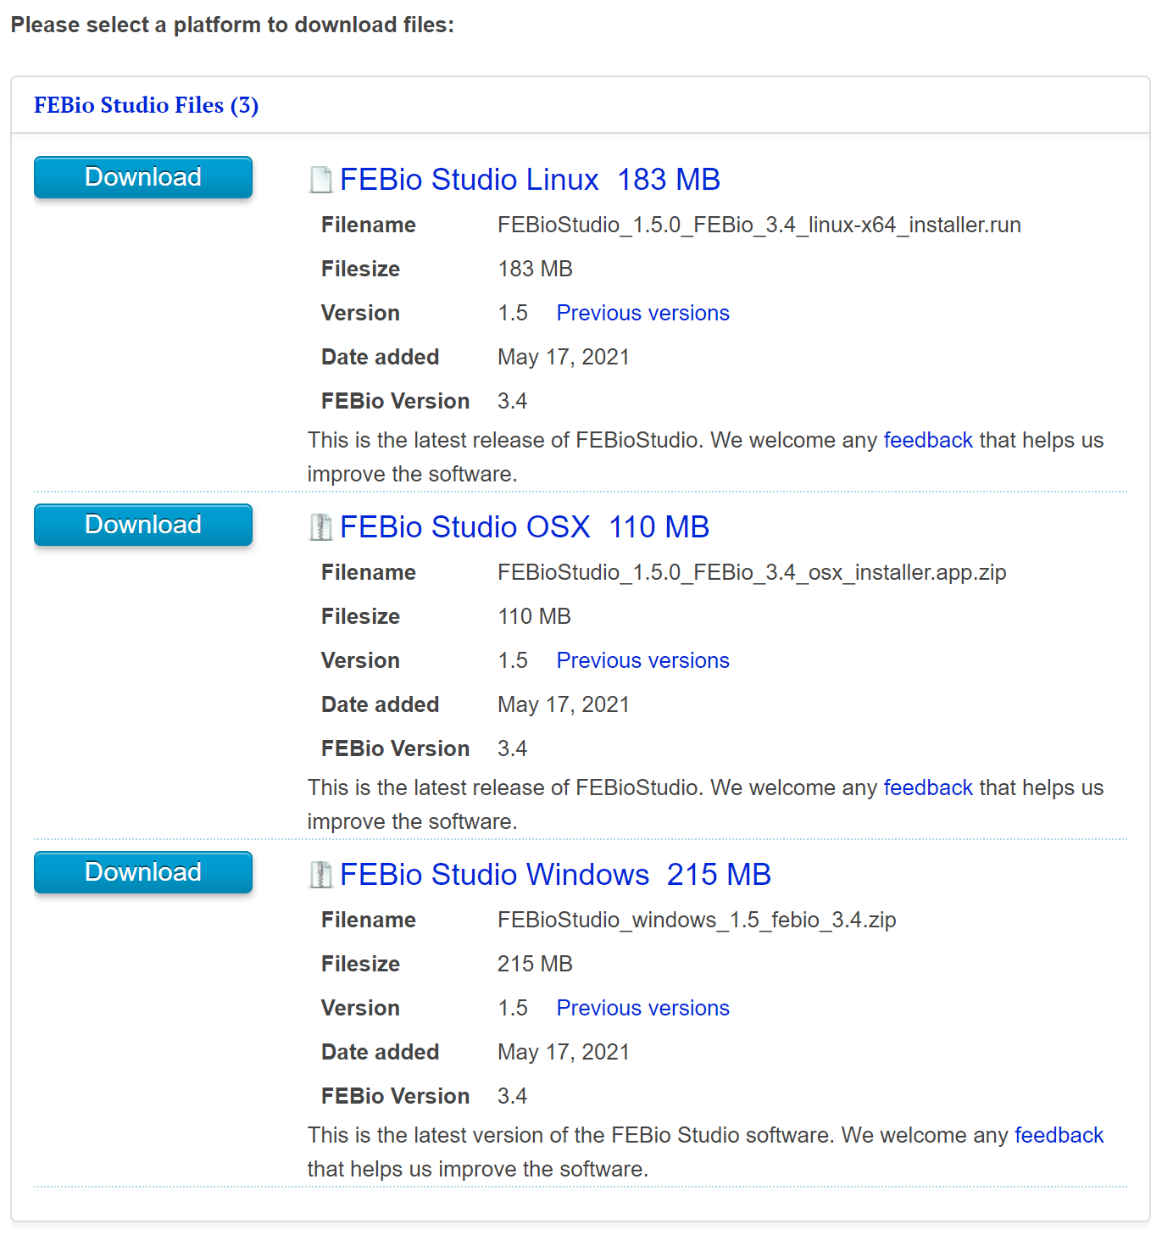
        + First - Linux users
        + Second - Mac users
        + Third - Windows users
  + Linux Downloads:
    - <https://febio.org/knowledgebase/getting-started/installing-febio-studio-on-linux/>
  + Mac Downloads:
    - <https://febio.org/knowledgebase/getting-started/installing-febio-studio-on-macos/>
  + Windows Downloads:
    - <https://febio.org/knowledgebase/getting-started/installing-febio-studio-on-windows/>
    - Open the file
    - Extract all
    - Double click to open the application
    - Click next and then accept the terms and conditions
    - Keep clicking next until the app installs
    - Once installed, check the box that says “launch” and then hit finish
    - If FEBio was installed correctly, you should see this window when first opened:

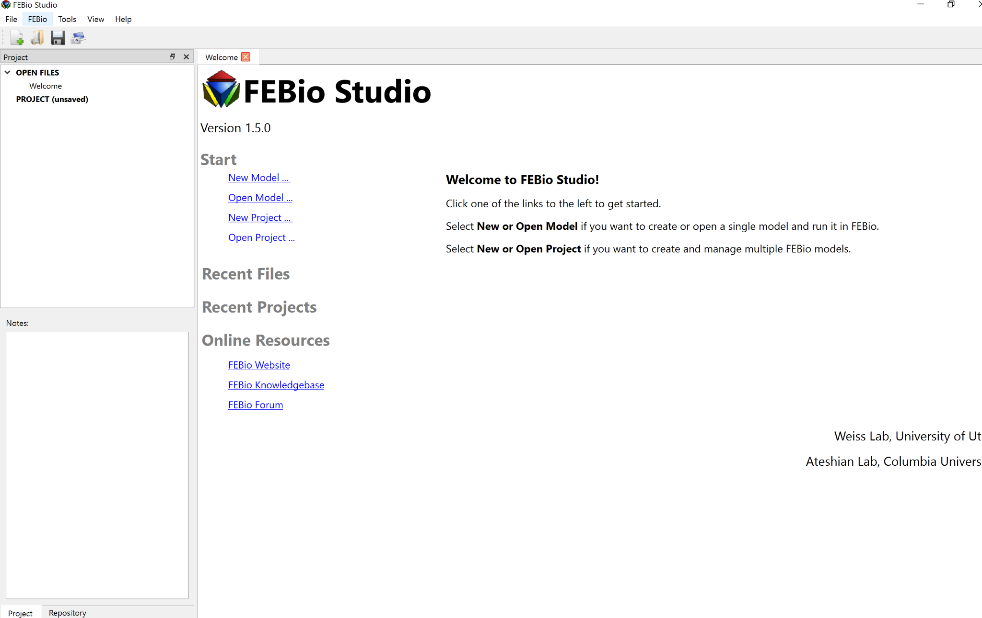

* + Overall, no software restrictions. Program is CPU-based so its capabilities are mostly dependent on the CPU power and RAM. Most recent laptops should be able to adequately run this program. Instructions are also consistent across all platforms.

#### Resources

* FEBio User Manual on how to use all of its functions
  + <https://help.febio.org/Manuals/FEBioUser/index.html>
* Tutorials from FEBio Website (all documents no videos :( )
  + <https://febio.org/knowledgebase/tutorials/performing-a-mesh-convergence-study/performing-a-mesh-convergence-study/>
  + Performing a mesh convergence study
  + Intro to FEBio Studio
  + Fluid Mechanics
  + Multiphasic Analysis
  + Model Repository
  + Model Building
* Introduction to FEBio Studio: <https://www.youtube.com/watch?v=I3_PKL4x45g>
* Example of simple CFD model <https://febio.org/knowledgebase/tutorials/fluid-mechanics/creating-your-first-cfd-model-in-febiostudio/>
* FEA Folder contains useful resources (Navigate to FEA -> Current -> Software):
  + FeBio Practice
    - Blood vessel model (haven’t attempted using the file)
  + Simulations Procedures (FeBio)
    - Contains a document and a video describing the process of running a simulation.
    - Very helpful in understanding how FeBio works and how to run simulations for the purposes of our task.
  + Simulation (FeBio)
    - Set of simulations of components with data from different materials
* Information from CFM
  + Modeling Drive > LAA LA CFM > Current > Software Research > CFM Software Research word doc

#### Creating Fluid Domain in SolidWorks

* <https://www.youtube.com/watch?v=V1zHcBw7hCA> - reference video
* For an assembly
  + Open the assembly
  + Go to Insert Components, click the expand arrow, select New Part
    - Recommended: rename the new part to Fluid or Internal Volume
  + Right click the new part and select Edit Part
  + Go to the Insert tab at the top of the screen and select Features > Join
    - Select all of the existing parts in the assembly, click the green check mark
  + Right click the part and select Open Part (this opens the part in its own window)
  + Create Planes at the ends of the part, similar to caps
    - Reference Geometry > Plane works well
  + In Features, choose the Intersect command
    - Select the two end planes as well as the Join solid, and then hit Intersect
    - Uncheck Merge result
    - Under Regions to Exclude, exclude all regions except the internal volume
    - Hit the green check mark
  + If done correctly, the intersect command should have created a new solid of the internal volume. Save this file as an STL file.
* For a part file
  + Skip to the instructions after Open Part and follow the same steps

#### 

#### Instructions for Importing a SolidWorks File

* Start by creating a New Project
* From there, create a new model within this project
* For our purposes, we will be using a Fluid Mechanics model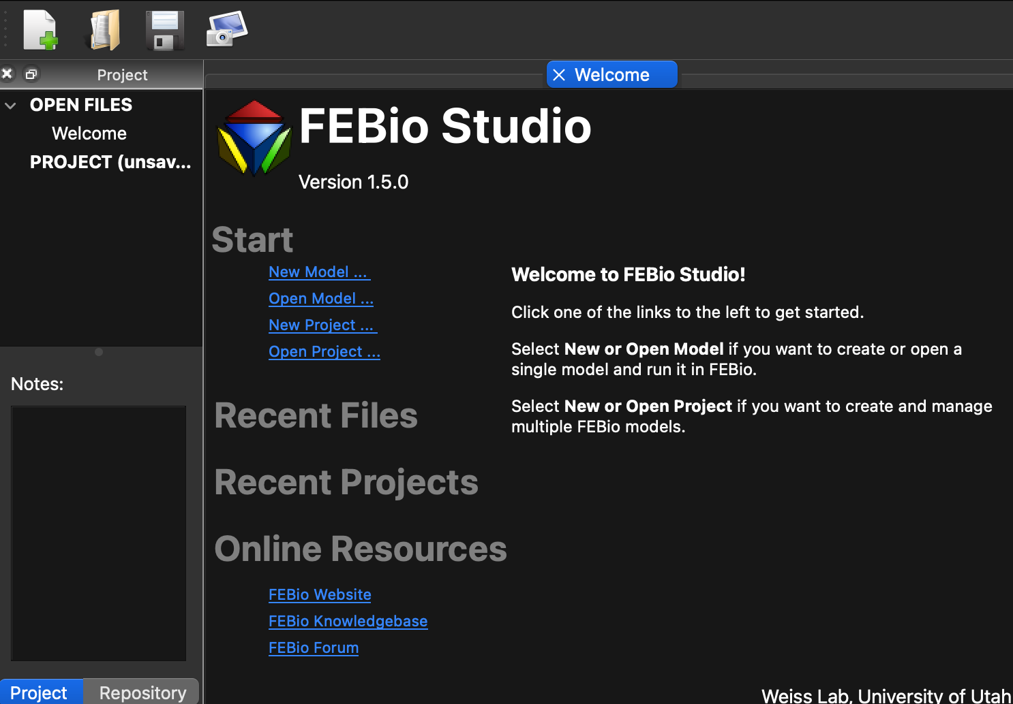
* Now, at the top of the screen, navigate to File -> Import Geometry
  + Importing models are for previously used FeBio models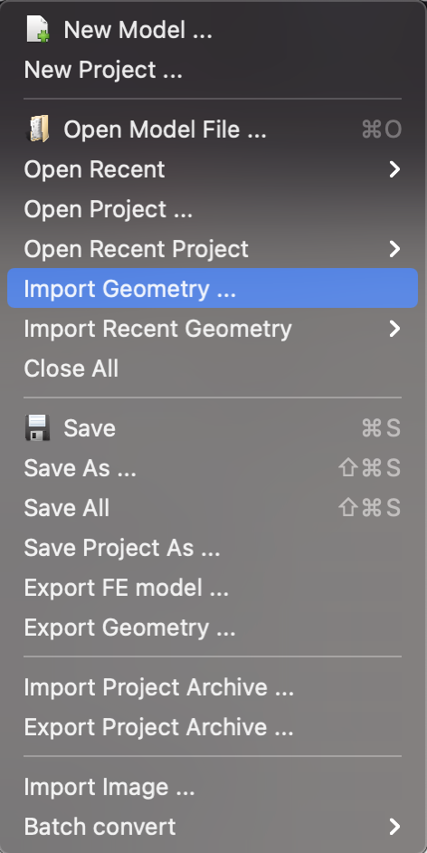
  + As an STL file is comprised of a series of triangles, it is a geometry that FeBio is able recreate
* Navigate to the appropriate file and import it
* Add a mesh to be able to use this model in the simulation
  + Select the part, go to Mesh, and select Apply

#### Test Simulation Progress/Comments

* Importing the file was easy
  + New Project > New Model > Import Geometry > Mesh > Apply
  + 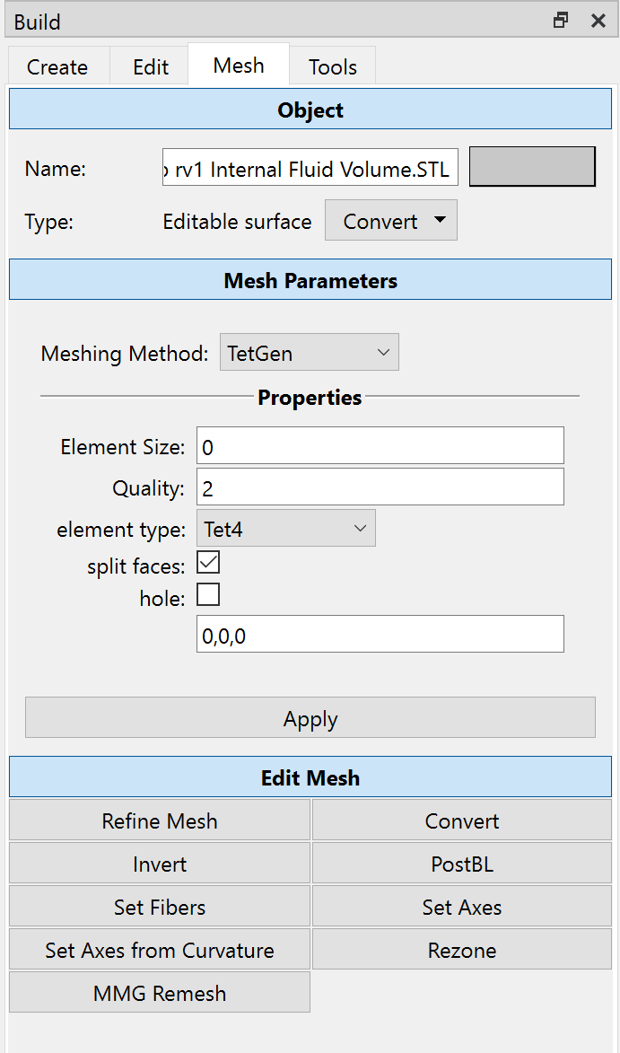
    - What mesh parameters are we supposed to be using? I just used the default ones.
* Initial
  + Boundary conditions
    - 
    - Zero fluid velocity for the walls (same as no-slip)
    - Zero fluid dilatation for outlet
    - Zero fluid dilatation for inlet rim
  + Loads
    - Fluid normal velocity for inlet face
    - Optional: fluid backflow stabilization
    - Optional: fluid tangential stabilization
  + Initial conditions
  + Contact
  + Constraints
    - 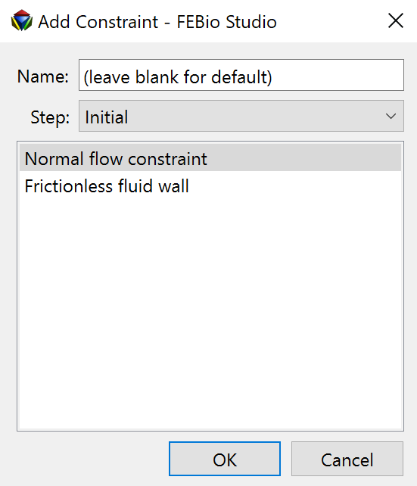
  + Rigid constraints
  + Rigid connectors
* Output
  + Plotfile
    - You can edit these plot variables by selecting which you want visible
      * Fluid acceleration
      * Fluid density
      * Fluid dilation
      * Fluid mass flow rate
      * Fluid pressure
      * etc...
  + Logfile
    - You can edit the type (node, element, rigid body, rigid connector) and enter a delimited list of variables

### 

### ANSYS

#### Software Specifications/Requirements

* Supported platform and operating system: Microsoft Windows 10, 64-bit
* Minimum hardware requirements:
  + Processor(s): Workstation class
  + 4 GB RAM
  + 25 GB hard drive space (connected hard drive applicable)
  + Computer must have a physical C:/” drive present
  + Graphics card and driver: Professional workstation class 3-D
  + OpenGL-capable
* Recommended hardware specifications:
  + A processor with at least 4 cores
  + 4 GB (or higher) graphics card
    - NVIDIA cards have shown good results
  + 16-128 GB of RAM based on problem size
  + Two 1 TB PCIe hard drives in a RAID 0 configuration
    - This is the fastest performance configuration and should provide plenty of space for analysis models
  + A hardware RAID controller and not a software RAID controller
    - Software RAID controllers can actually hurt performance
  + 17" or larger flat panel display
    - Dual monitors are often desirable

#### Features

* Fully integrated into the ANSYS Workbench environment, which incorporates both the modeling and fluid simulation computation
  + The Workbench allows either importing 3D models from CAD softwares such as SolidWorks and adding features such as meshes prior to fluid simulation or creating a 3D model from scratch and adding necessary features prior to simulation
* Can solve sophisticated models for multiphase flows, viscous and turbulent flows, internal and external flows, etc.
* Allows examination of interactions caused by multiple physics, such as fluid-structure interaction (FSI)
* Includes shape optimization tools that can adjust geometric parameters in model until optimization goal is met
  + - Uses the adjoint solver to modify the mesh from within to test effects of recommended changes

#### Steps to Download

* Go to the student installation link (<https://www.ansys.com/academic/free-student-products>)
  + Scroll down to “Ansys Student” and click on Download Now
  + Click on Download ANSYS Student 2021 R1
  + Extract (unzip) the downloaded installation files
  + Right-click on setup.exe and select Run as Administrator (This will run setup.exe from the extracted files.)
  + Read and accept the clickwrap to continue
  + Click the right arrow button to accept the default values throughout the installation
  + Click the exit button to close the installer
* Instructions for accessing ANSYS through virtual lab (copied from CFD Procedures)
  + Go to<https://mycloud.gatech.edu/vpn/index.html>, enter your Georgia Tech login information, and install Citrix Receiver when prompted
  + After opening Citrix Receiver, you will reach a page with the tabs Home, Apps, and Desktop → click on Desktops → BME-2021 → Open
  + Once loaded into the remote desktop, enter “About your PC” into Windows search bar and look for the remote desktop number being used within Device Name (should have the syntax BME-2021-#)
    - Every time you log into a remote desktop to use ANSYS, you will need to record the date and time you logged in, remote desktop number used, and time you log off when you do (recommended to create a Word document to maintain this log)
  + Search “Workbench” in Windows search bar to open ANSYS Workbench
  + To import geometry, when browsing, go to local disk and open the FMT shared drive
  + In order to open files from your PC, will need to copy the files onto a flash drive and locate the flash drive within Windows Explorer of remote desktop
    - If a window appears asking for permission to access local files, select read and write
    - NOTE: as of now, BME-2021 VLab still uses ANSYS 2020 and SolidWorks 2020, so you cannot open ANSYS 2021 and SolidWorks 2021 files within VLab (you can install full version of SolidWorks 2021 locally on your PC through Georgia Tech)

#### Resources

* See CFD Delivery System Procedures document for detailed instructions on running a simulation
  + Under CFD Protocol in ANSYS > ANSYS Fluent
* See example video of setup and running a simulation
  + Modeling > Delivery System CFD > Current > Software > ANSYS Fluent Simulation Example
* Copied from External References for Protocol in the procedures document
  + Parts 1 and 2 Video Tutorial: <https://www.youtube.com/watch?v=NYwnLIdBBqw>
    - Additional reference for Part 2: <https://www.youtube.com/watch?v=_AII6cpzos8> (from the 7-minute mark onwards)
  + Part 3 Video Tutorial: <https://www.youtube.com/watch?v=rueRyqPHjNc>
  + Part 4 Video Tutorial: <https://www.youtube.com/watch?v=JqpSGGNm9ss> and <https://www.youtube.com/watch?v=B4hZdMDmSOA>
  + Step-By-Step Instructions with Images for All Steps Involving ANSYS Workbench (After Modifying Model in SolidWorks): <https://drive.google.com/drive/u/0/folders/0By-hZbg-3WSveVZ0NlZKZjFzTEU>
* <https://www.youtube.com/watch?v=fxFZyiWt_Xc> - Basic Ansys tutorial, shows Geometry -> Mesh -> Simulation steps
* From CFM
  + Modeling > LAA LA CFM > Current > Software Research > Ansys folder or CFM Software Research word doc
  + Modeling > LAA LA CFM > Current > CFD Example > Videos w o Audio > two videos ANSYS Demo_Geometry and Mesh, ANSYS Demo_ Meshing and Fluent

#### Instructions for Importing a SolidWorks File and Creating Fluid Domain

STEP file with DesignModeler

* Save the SolidWorks part as a STEP file (.stp)
* Open ANSYS Workbench application
* Double-click on Fluid Flow (Fluent) within Toolbox
  + Within Cell A, right-click Geometry, click Import Geometry, click Browse, find the .stp file
  + Once the file is selected and there is a check mark next to Geometry in Cell A, right-click Geometry → click Edit Geometry in DesignModeler
  + Once in DesignModeler, click Generate (with the lightning bolt next to it) and wait till part shows up within Tree Outline
  + Make necessary adjustments depending on the part and desired simulation, for simulations involving the catheter with open ends, you will need to create caps
    - Copied from CFD Delivery Systems Procedures > CFD Protocol in ANSYS
    - To create the inlet and outlet caps for your model, click on Concepts at the top → Surfaces from Edges → ctrl+select the outermost edges of your desired internal fluid domain (each circular edge is usually separated into two so make sure you have the entire edge selected for all inlet and outlet faces) → click Apply on the bottom left hand side → click Generate near the top
    - Click on Tools → Fill → next to Extraction Type, change By Cavity to By Caps (if you want to fill through specific bodies inside entire fluid domain only, select them under Target Bodies; else leave as All Bodies) → click Generate near top again
    - Expand the Parts under Tree Outline → there should be a part named “Solid” corresponding to the filled fluid domain → right-click and rename it to “Fluid” if preferable and right click on all other parts you don’t want included in fluid domain → click Suppress Solid Bodies → ensure that only desired fluid domain is seen
  + Close the page and return to Workbench
* Within Cell A, right-click on Mesh → click Edit
  + Optional but recommended: name each face depending on function (for example “velocity inlet” for face where fluid will enter through and “pressure outlet” for face where fluid will exit through, “walls” for the sides of the fluid domain)
    - Select each face, right click, and click Create Named Selection
    - Control click to select multiple faces for one named selection
  + Right click Mesh within Tree Outline and click Update to add meshing

STL or STEP file with SpaceClaim

* Save the SolidWorks part as an STL file (.stl) or STEP file
* Open ANSYS Workbench application
* Double-click on Fluid Flow (Fluent) within Toolbox
  + Within Cell A, right-click Geometry, click Import Geometry, click Browse, find the .stl file
  + Once the file is selected and there is a check mark next to Geometry in Cell A, right-click Geometry → click Edit Geometry in SpaceClaim
  + Once in SpaceClaim, go to File > SpaceClaim Options at the bottom of the window > Units to make sure you are using the correct units. Click cancel to exit.
  + For STL files: Right click Facets on the left and select Convert to solid > Merge Faces
* Creating Fluid Domain (for most simulations we will be performing we need an internal fluid domain inside the catheter)
  + Once you have the Solid part, go to the Prepare tab and click on Volume Extract
  + Choose the Select Faces option and select the faces that enclose the region (for a catheter use the end faces of the tube)
  + Choose the Select Seed Face icon and select a face within the volume you want to enclose (for a catheter use the inside wall)
  + Click on the green check mark. Once the volume is converted to a solid part, delete the original solid that encompassed the volume/fluid domain
  + Close the page and return to Workbench
* Within Cell A, right-click on Mesh → click Edit
  + Optional but recommended: name each face depending on function (for example “velocity inlet” for face where fluid will enter through and “pressure outlet” for face where fluid will exit through, “walls” for the sides of the fluid domain)
    - Select each face, right click, and click Create Named Selection
    - Control click to select multiple faces for one named selection
    - Can use smart select and double click to select similar faces
  + Right click Mesh within Tree Outline and click Update to add meshing

<https://www.youtube.com/watch?v=_sIMaid9tQ4> - SpaceClaim simplifying a mesh, converting to a solid

<https://discoveryforum.ansys.com/t/x14q9z> - STL/Facet Editing

<https://www.youtube.com/watch?v=4_WFWUho_ko> - Creating fluid domain in SpaceClaim

<https://www.youtube.com/watch?v=1DWdjPA9rjA> - Using volume extract in SpaceClaim

<https://www.youtube.com/watch?v=ttHmvYuVHWU> - tips on meshing in context of CFD

#### Post-processing Results

* Copied from CFD Delivery Systems Procedures document
* Double-click on Solution within ANSYS Workbench and click on the Results tab at the top of screen
* To create a **contour**, within the Graphics section on the top, click **Contour** → name contour if needed → under Contours of, specify either **Pressure, Velocity, etc.** → specify specific type of contour (most common ones are **Total Pressure** and **Velocity Magnitude**) → click all surfaces you want to include within contour → click Save/Display to display contour
  + In order to obtain contour of **cross-section of model**:
    - Within Surface section on the top, click Create → Plane → name it for identification → specify orientation of plane (either XY, YZ, ZX, a point and normal vector, or three points) → specify length along the coordinate that remains constant in the plane (applies for XY, YZ, or ZX planes) → click Create
    - Click on Contour and repeat all steps above except for selecting the plane for the surface
* To create a **numerical plot**, click Create under Surface section → Line/Rake → name line for identification → check “Line” and click Reset → Specify Type: Line → for the End Points, specify first and last x, y and z coordinates (if wanting to create line only along x, y or z axes, specify first point at -10 and last point at 10 for that axis to encompass the entire model, and leave the other axes the same) → Create
  + Next, click on XY Plot under Plots section → New → name plot for identification → specify plot direction (depends on direction of line) → specify function to plot (**Pressure, velocity, etc.**) and the section below that → keep X Axis Function as “Direction of Vector” → choose the line under Surfaces → click Save/Plot to obtain a parameter as a function of distance for the model
* Additional post-processing tools: **Vectors, Pathlines, Particle Tracks, etc.**

#### 

#### Test Simulation Progress/Comments

* See Modeling > Delivery System CFD > Current > Software > ANSYS Fluent Simulation Example
* Importing the .stl file was easy
* The volume extract tool worked very well in SpaceClaim
* Used inaccurate boundary conditions but was able to view results
* Overall, the process was straightforward and did not take very long

#### Simulation Results

Option 1

4 inches water:

* Images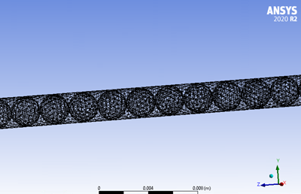

Mesh: Scaled Residuals: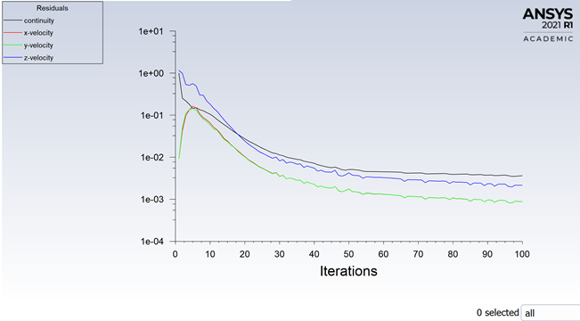

2D Velocity Contour at Inlet End: 2D Velocity Contour at Outlet End:

2D Velocity Contour of Outlet face Dynamic Pressure Contour at Walls-Volume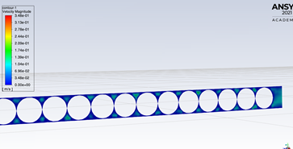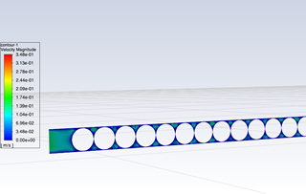

* Values (from CFD Post Function Calculator)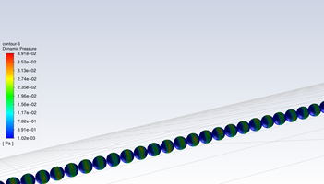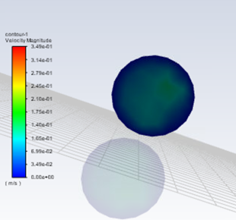
  + Max velocity at outlet = 0.145204 [m s^-1]
  + Average velocity at outlet = 0.0746979 [m s^-1]
  + Max pressure along walls-volume = 105784 [Pa]
  + Average pressure along walls-volume = 52689 [Pa]

24 inches water:

* Images

Contour of Static Pressure Scaled Residuals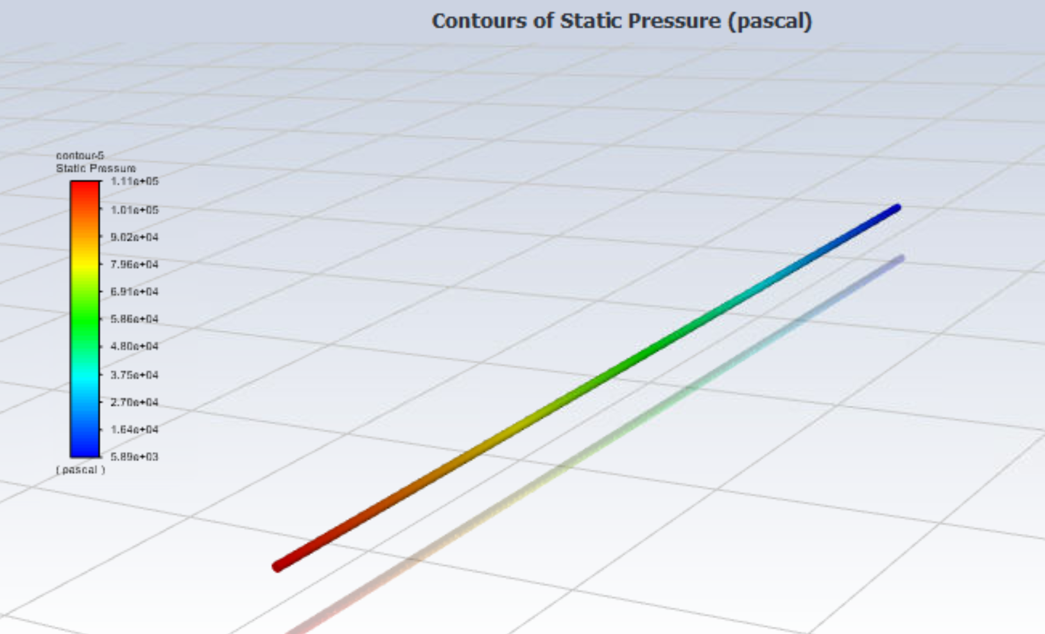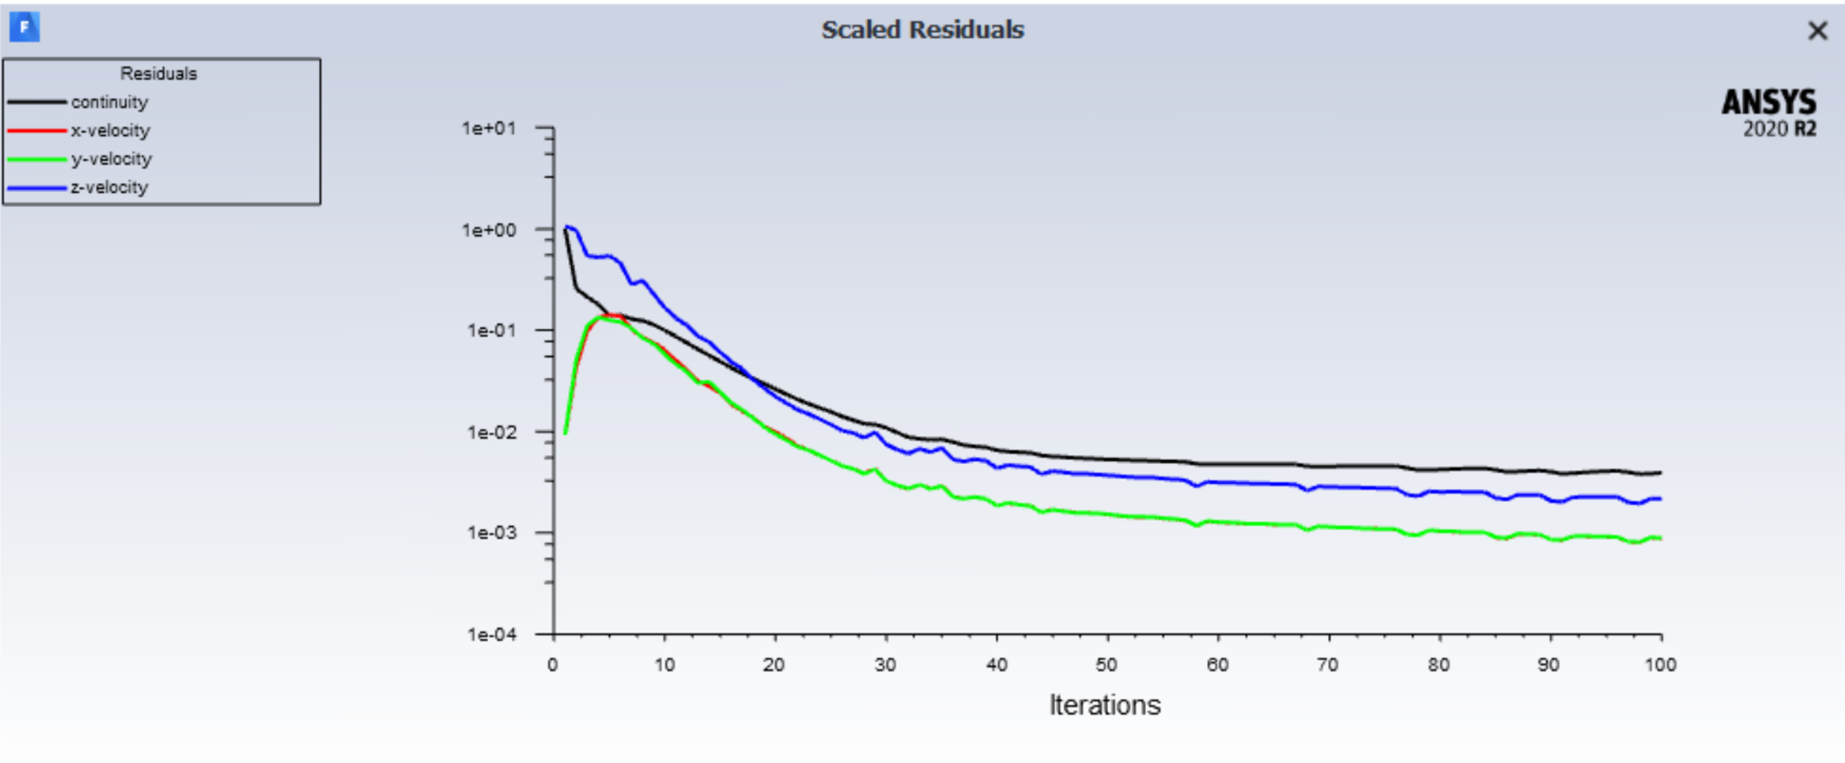

2D Velocity Contour of Inlet End 2D Velocity Contour of Outlet End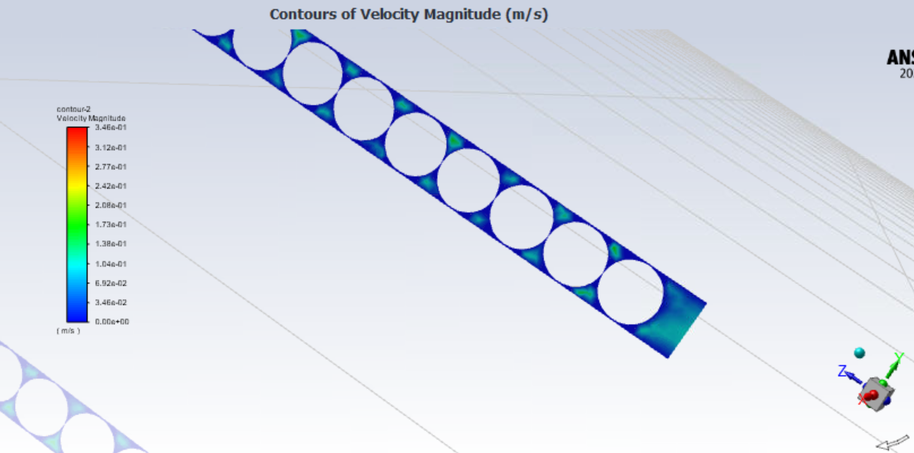

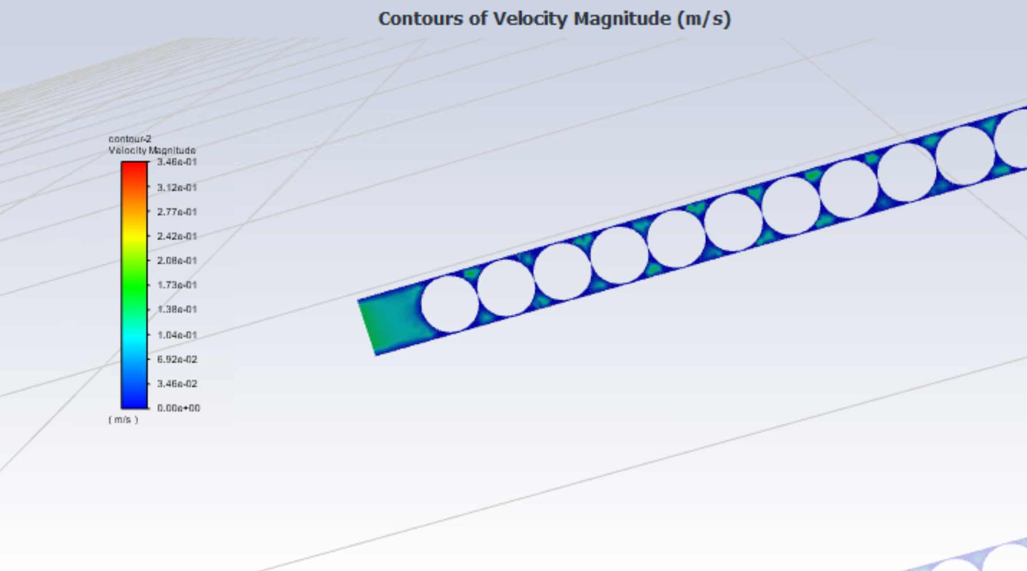

2D Velocity Contour of Outlet Face Dynamic Pressure Contour of Walls-Volume

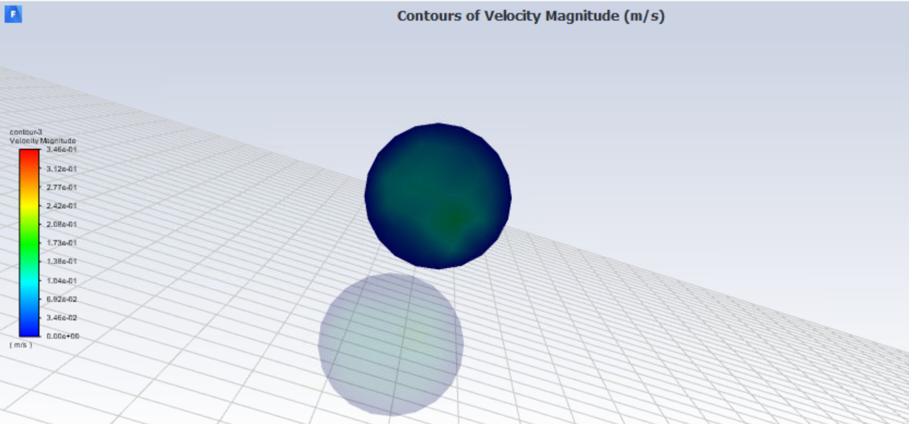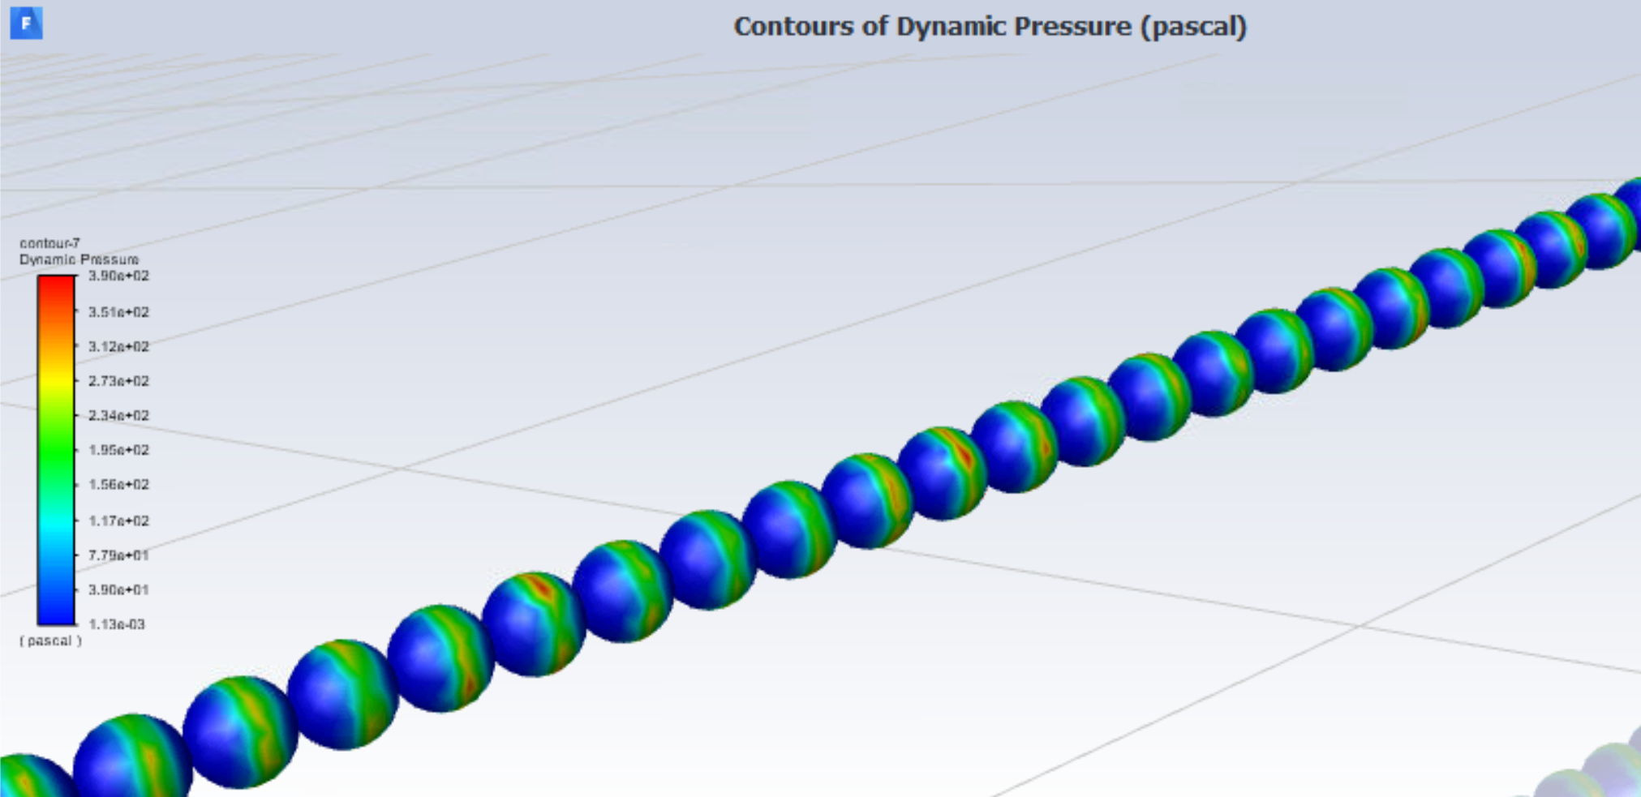

* Values
  + Max velocity at outlet = 0.151087 [m s^-1]
  + Average velocity at outlet = 0.0771769 [m s^-1]
  + Max pressure along walls-volume = 111253 [Pa]
  + Average pressure along walls-volume = 58379 [Pa]

Option2